LAB 2 – Improved Movement

______________________________________________________________

TASKS

1. Sign in to the lab and sign out a robot. Attendance goes towards CA.
2. Read the Webcourses lab 2 material
   1. Movement – Speed and Direction
   2. Movement – Improved Movement (Principles of PID)
   3. What does PID stand for?
3. Rebuild the Robot from last week.
4. Fix your programs from last week and enable the PID algorithm and show you can follow a line for 2 meters.
5. Put the wheels in sync so that holding one wheel stops the other one.
6. Modify code so only one motor is set power and it moves in a straight line.
7. Build the challenge layout below or something similar.

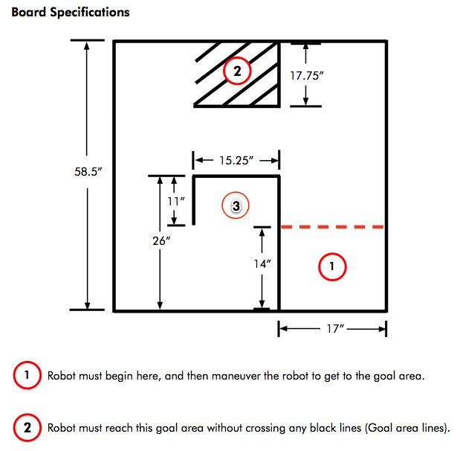

1. Write a program which uses PID and Synchronized moters to go from label 1 to label 2 without crossing the lines.
2. Modify the program so that it may randomly decide to go to point 3 instead of 2. See <http://www.robotc.net/wiki/Math#rand> for help on the rand function.
3. Modify the program such that it can still go to point 2 or 3 randomly but decides on a random speed to use at the start of the program. It should take the same route in all cases, just use a different speed.

**motor**[motorB] = (**rand**() % (max-min)) + min; // set motorC to a random number in the range: [min, max]

1. Complete the Lab Logbook and give to your lab tutor.
2. Sign back in the robot

Copies of the lab logbook will be provided in each lab (also available in Webcourses). Logbooks are individual, not group based.